**# 1. Create a vector of 25 random integers between -100 and 100, show negatives and positions**

v <- sample(-100:100, 25, replace=TRUE); data.frame(pos=which(v<0), val=v[v<0])

Output :

**# 2. Extract only the port number from an IP string**

sub(".*:(\\d+)$", "\\1", "172.168.45.112:3306")

Output :

**# 3. Simulate machine status log (1000 entries, ratio 6:2:2) and find percentages**

prop.table(table(sample(c("working","faulty","maintenance"),1000,TRUE,c(0.6,0.2,0.2))))*100

**Output :**

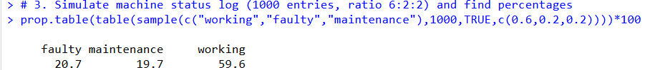

**# 4. Generate 100 real numbers (0–100) and count numbers in [25,50]**

sum((x<-runif(100,0,100))>=25 & x<=50)

**Output :**

**# 5. Replace 3rd element of each vector in a named list**

L <- list(1:5, letters[1:5], c(TRUE,FALSE,TRUE)); L[[1]][3]<-999;L[[2]][3]<-"NEW";L[[3]][3]<-FALSE;L

**Output :**

**# 6. Convert non-NA character elements to uppercase, keep NAs unchanged**

x <- c("hello",NA,"world"); x[!is.na(x)] <- toupper(x[!is.na(x)]); x

**Output :**

**# 7. Replace names starting with 'A' in a data frame with 'Anonymous'**

df <- data.frame(name=c("Alice","Bob","Ankit","Sara"),score=1:4); df$name <- sub("^A.*","Anonymous",df$name); df

Output :

**# 8. Coerce mixed numeric/character vector to numeric and compute mean excluding NAs**

mean(as.numeric(c("10","20","x","30")), na.rm=TRUE)

**Output :**



**# 9. Extract elements where logical vector is TRUE from a named list**

L <- list(even=2:10, char=c("a","b"), logi=c(TRUE,FALSE,TRUE)); L$even[L$logi]

**Output :**



**# 10. Sequence 50 to 5 step -2, show values divisible by 3**

(seq(50,5,-2))[seq(50,5,-2)%%3==0]

**Output :**

**# 11. Replace 3rd, 6th, 9th elements with 'NA_val' and find non-numeric entries**

v <- sample(1:100,10); v[c(3,6,9)]<-"NA_val"; v[is.na(as.numeric(v))]

**Output :**



**# 12. Remove punctuation from string vector**

gsub("[[:punct:]]","",c("Hi!","Test#","Data@Sci","R?","Clean."))

**Output :**

**# 13. Return maximum value from each vector in a list**

lapply(list(1:5,c(3,9,1),c(-2,-9,-1)),max)

**Output :**

**# 14. Frequency table of sampled vector ('low','medium','high') sorted decreasing**

sort(table(sample(c("low","medium","high"),50,TRUE)),decreasing=TRUE)

**Output :**

**# 15. Vectorized operations (addition, multiplication) on unequal length vectors**

a<-1:5; b<-1:3; a+b; a*b

**Output** **:**

